|  |  |  |  |  |  |
| --- | --- | --- | --- | --- | --- |
| Date | 6-Dec-22 | | | Tester Name | Janette Paus |
| Environment | Penfax - Test 2 | | | Login used |  |
| Operating System | Windows | Version: 21H2 | Update Number: | | |
| Software Used | Select Software | Version: 107.0.1418.56 | Update Number: | | |
| Select Software | Version: | Update Number: | | |
| Application Release version | R22.4.1 | | | | |
| Test Case Title | E20.06b | | | | |
| Test Type | Regression | | | | |
| Test Scenario | Cancel an Interfund Transfer (same day) | | | | |
| Expected Results | To cancel an interfund transfer same day, where it shows in pending status, and the status of that instruction changes to cancelled.  Cancel one processes on PENWEB and another processed on PENFAX to ensure both can be cancelled.  There should be no funds moved during the overnight processing | | | | |
| Pass/Fail | Select | | | JIRA# | <enter the new JIRA ticket number if the test case failed> |

Select a Member active in PEPP, with money in their account.

SID:284443

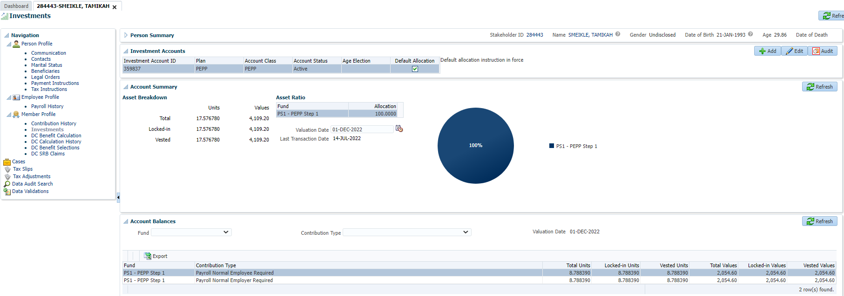

Scroll down to Account Instructions and add Deposit Allocation – Accelerated Growth Fund at 100% and click Save

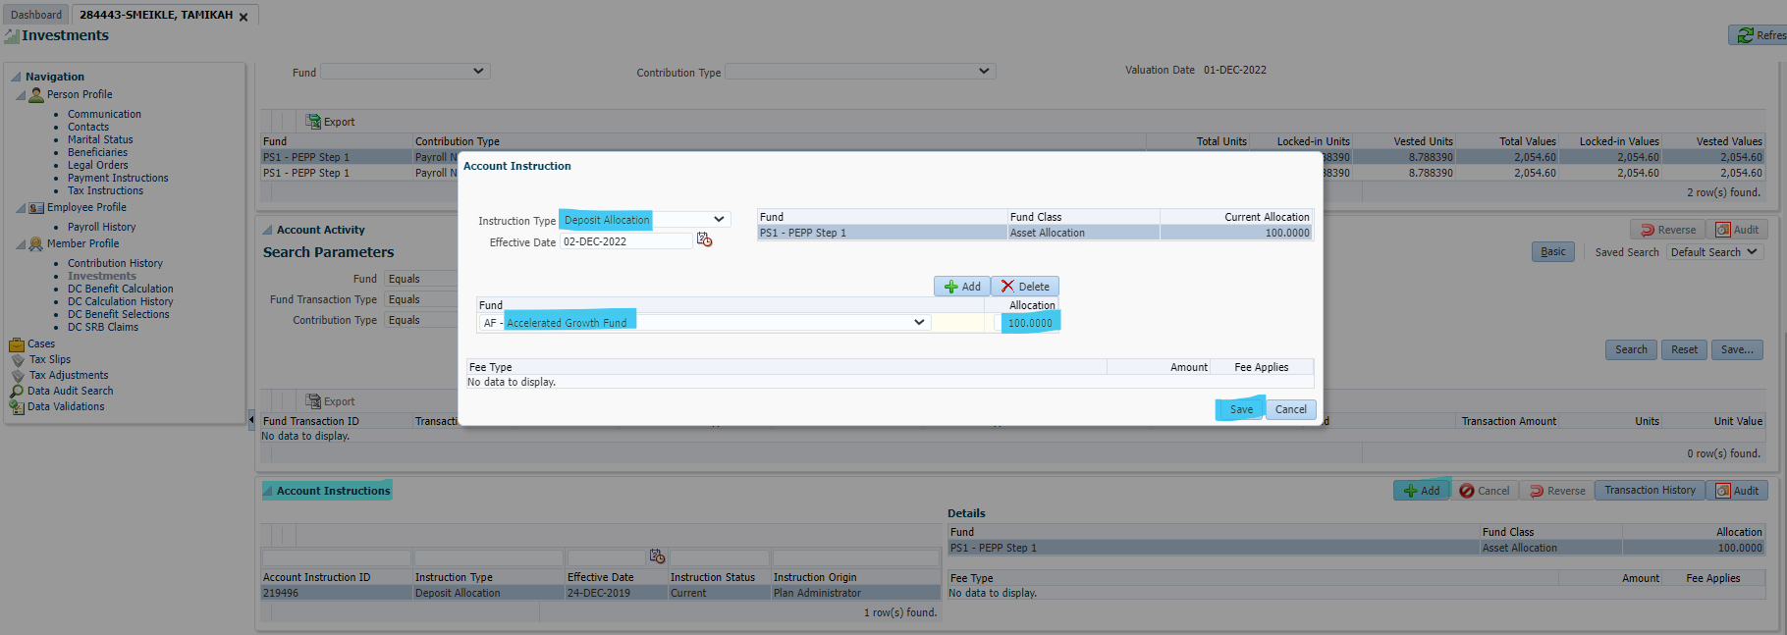

When the warning message appears, click Accept and Continue

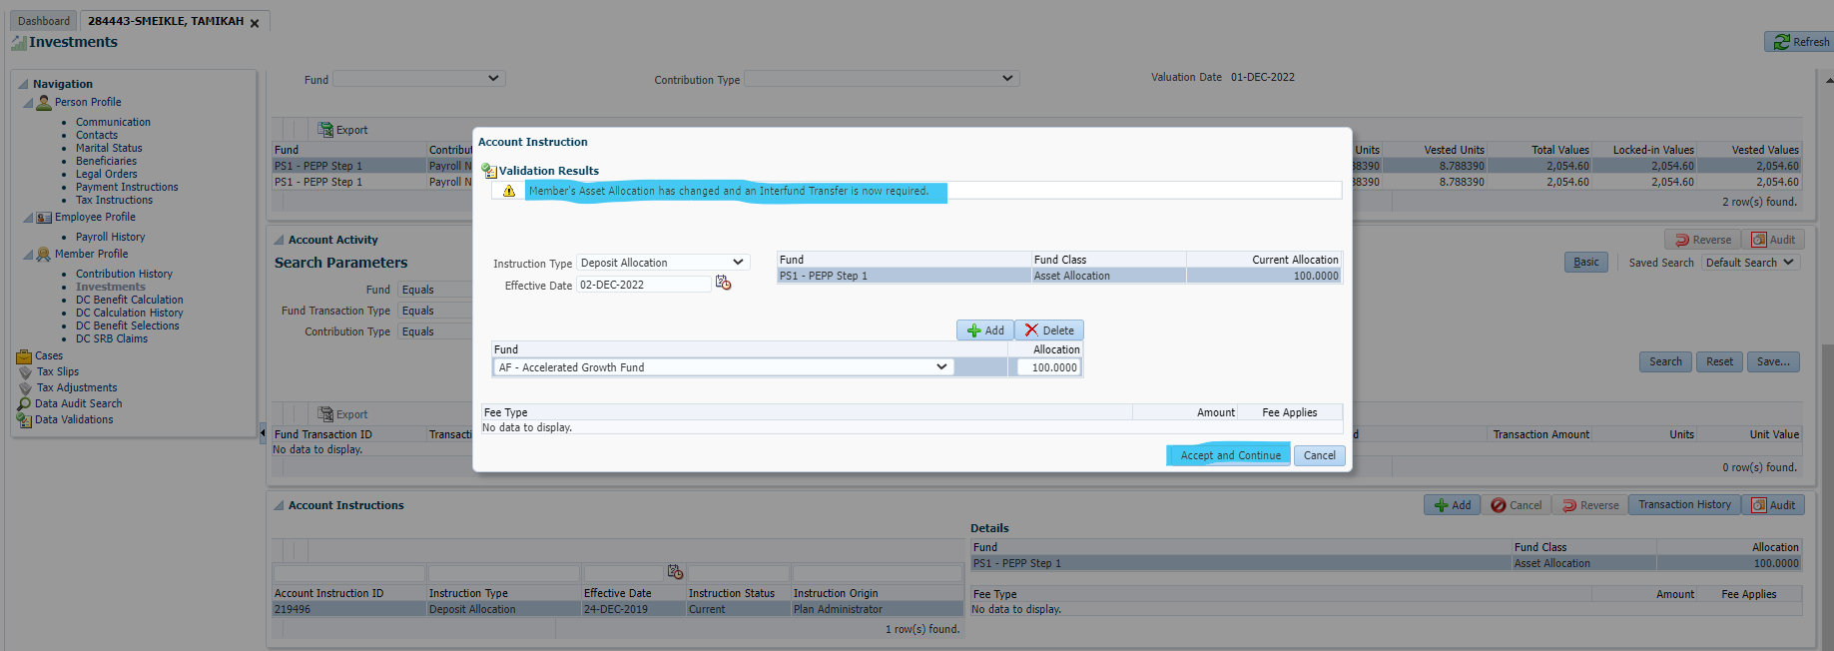

Added an Interfund Transfer from PEPP Step 1 to Accelerated Growth and click Save

(Note: Always use interfund advanced for transfers processed in house & percent if moving 100% of funds, basic is used for the ones added by members online through PENWEB):

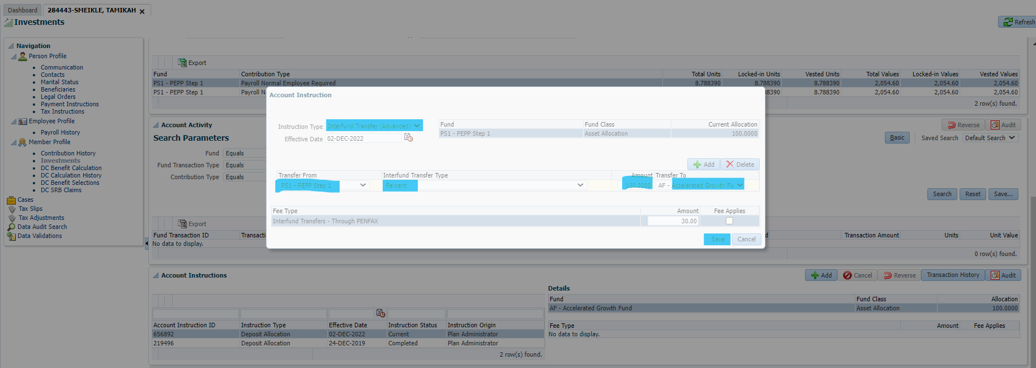

The transaction will show Pending status

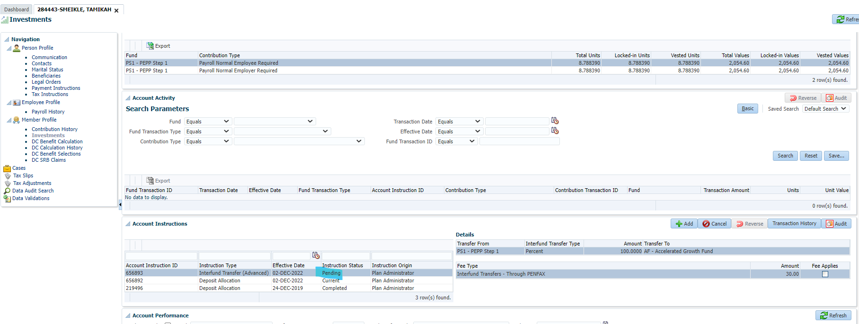

To reverse the transaction, highlight the Interfund Transfer (pending status) and click the Cancel button then click Yes

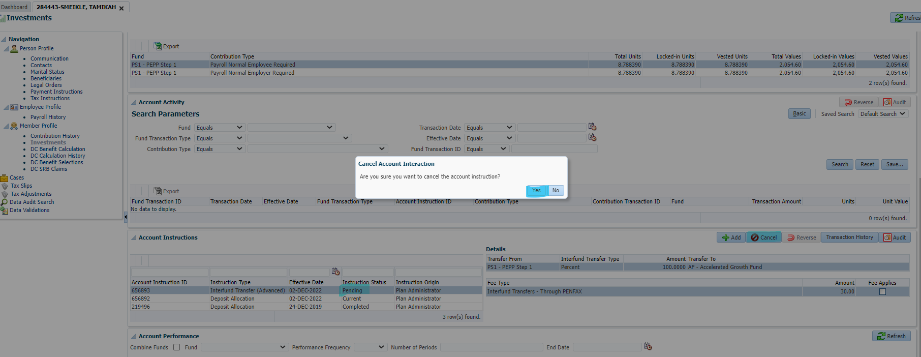

The status will change to Cancelled.

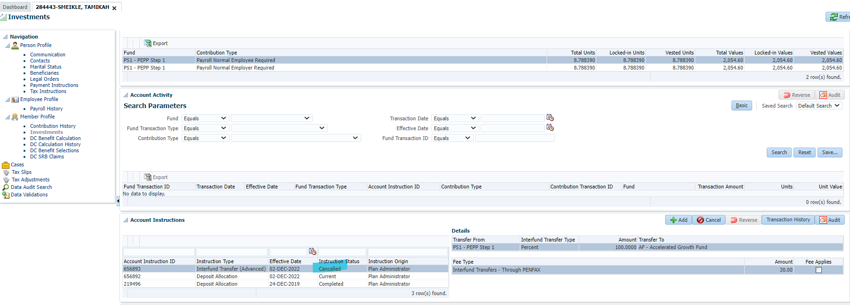

Add a new Deposit Allocation to PEPP Step 1 and click Save

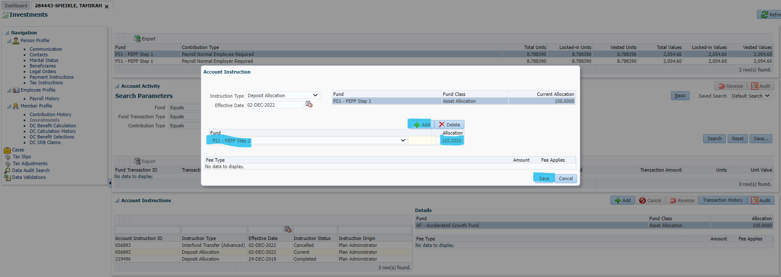

Confirm the next day that no money was moved from one fund to another.

December 5, 2022 – the funds show in PEPP Step 1 and haven’t moved.